STATISTICAL ANALYSIS
AND HYPOTHESIS TESTING
Customer Churn Dataset

A statistical investigation of satisfaction, contract type, and churn

1. Executive Summary
This report presents a statistical investigation of customer churn using a cleaned dataset of 10,000 customer records.
Three tests were conducted:
1.Welch’s independent-samples t-test compared satisfaction scores for churned and non-churned customers;
2.A chi-square test of independence examined the association between contract type and churn;
3.And a one-way ANOVA compared average satisfaction across contract types. The results show significantly lower satisfaction among churned customers and a statistically significant association between contract type and churn. The ANOVA did not find statistically significant differences in mean satisfaction across contract types.

2. Dataset and Preparation
The cleaned dataset contains 10,000 records and 16 columns, with no missing values remaining after cleaning. The Churn variable is coded as 0 for customers who did not churn and 1 for customers who churned. A significance level of 0.05 was used for hypothesis testing.

Dataset characteristic | Value
Total records | 10,000
Columns | 16
Did not churn | 7,740 (77.4%)
Churned | 2,260 (22.6%)
Missing values after cleaning | 0
Significance level | 0.05

3. Test 1 — Independent-Samples Welch t-Test
Research question: Do average satisfaction scores differ between customers who churned and customers who did not churn?
H₀: The mean satisfaction score is equal for churned and non-churned customers.
H₁: The mean satisfaction scores differ between churned and non-churned customers.
Welch’s t-test compares the means of two independent groups without requiring equal population variances.

Measure | Result
Non-churned customers | n = 7,740; mean = 6.8833; SD = 1.1913
Churned customers | n = 2,260; mean = 6.2987; SD = 1.2272
Mean difference (churned − non-churned) | −0.5846
t-statistic | −20.0563
Welch degrees of freedom | 3593.9094
p-value | 6.6833 × 10⁻⁸⁵
95% confidence interval | [−0.6418, −0.5275]
Cohen’s d | −0.4874

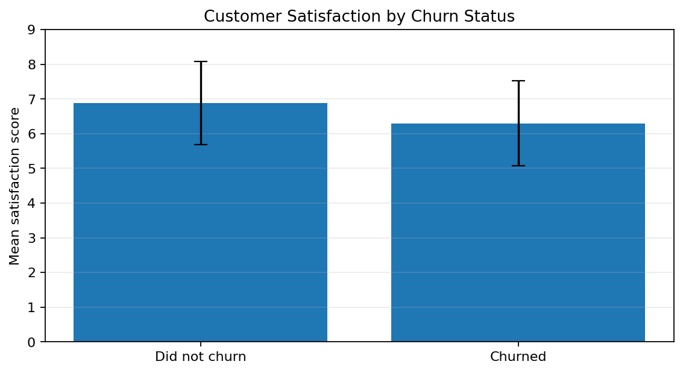
Figure 1. Mean satisfaction by churn status; error bars represent one standard deviation
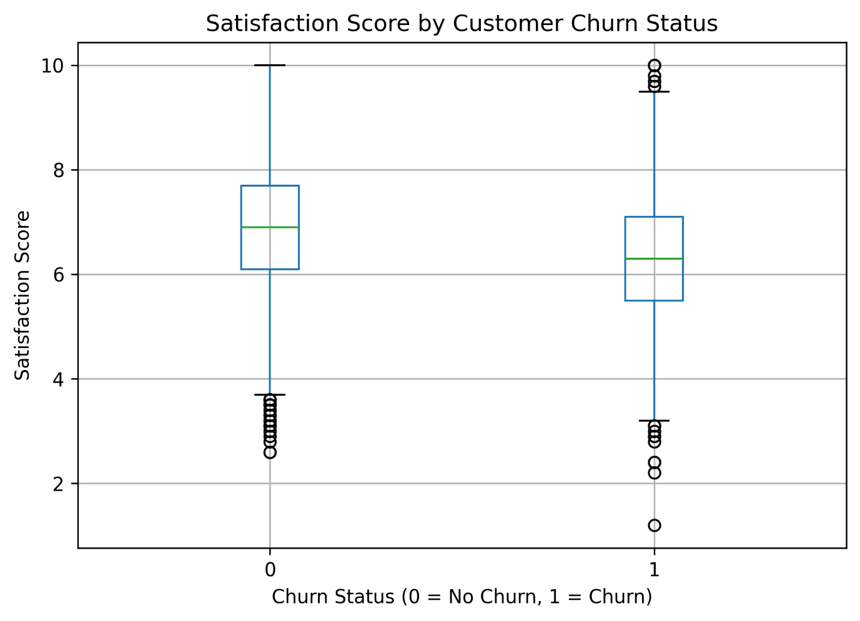
Figure 2. Mean satisfaction by churn status; box plot representation

Decision: Reject H₀ because the p-value is far below 0.05. Churned customers had a mean satisfaction score approximately 0.585 points lower than customers who stayed. The 95% confidence interval is entirely below zero. The absolute Cohen’s d value of about 0.49 indicates a moderate standardized difference. This association does not establish that lower satisfaction causes churn.

4. Test 2 — Chi-Square Test of Independence
Research question: Is customer churn associated with contract type?
H₀: Contract type and churn are independent.
H₁: Contract type and churn are associated.
The expected cell counts were all well above 5, satisfying the usual expected-frequency condition for the chi-square test.
Contract type | Did not churn | Churned | Total | Churn rate
Month-to-Month | 3,881 | 1,715 | 5,596 | 30.65%
One Year | 2,059 | 354 | 2,413 | 14.67%
Two Year | 1,800 | 191 | 1,991 | 9.59%
Total | 7,740 | 2,260 | 10,000 | 22.60%

Statistic | Result
Chi-square statistic | 486.4445
Degrees of freedom | 2
p-value | 2.3438 × 10⁻¹⁰⁶
Minimum expected cell count | 449.966
Cramér’s V | 0.2206

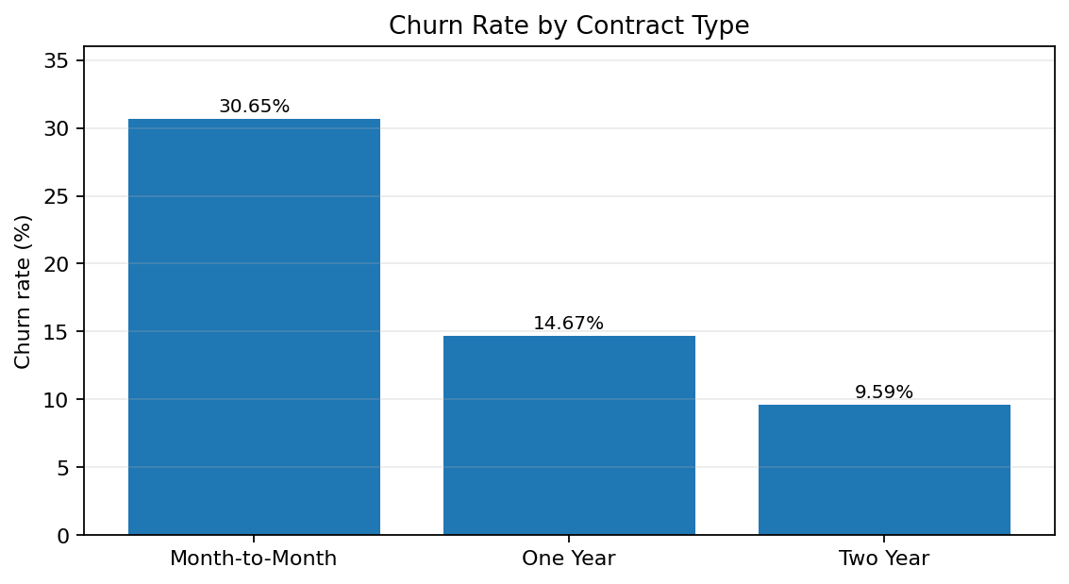
Figure 3. Observed churn rate by contract type.

Decision: Reject H₀ because the p-value is below 0.05. Contract type is statistically associated with churn. Month-to-Month customers had the highest observed churn rate (30.65%), followed by One Year customers (14.67%) and Two Year customers (9.59%). Cramér’s V of 0.2206 suggests a small-to-moderate association. The test does not establish causation or account for other possible influences on churn.
5. Test 3 — One-Way ANOVA
Research question: Does mean satisfaction differ among Month-to-Month, One Year, and Two Year contract customers?
H₀: All three contract groups have equal mean satisfaction scores.
H₁: At least one contract group has a different mean satisfaction score.
Levene’s test assessed equality of variances. Its p-value was 0.4171, providing no evidence of unequal variances at the 0.05 level.

Contract type | Count | Mean satisfaction | Standard deviation
Month-to-Month | 5,596 | 6.7302 | 1.2157
One Year | 2,413 | 6.7855 | 1.2400
Two Year | 1,991 | 6.7687 | 1.2279

Statistic | Result
Levene statistic | 0.8744
Levene p-value | 0.4171
ANOVA F-statistic | 1.9750
ANOVA p-value | 0.1388
Eta-squared (η²) | 0.000395
Variation explained by contract type | 0.0395%

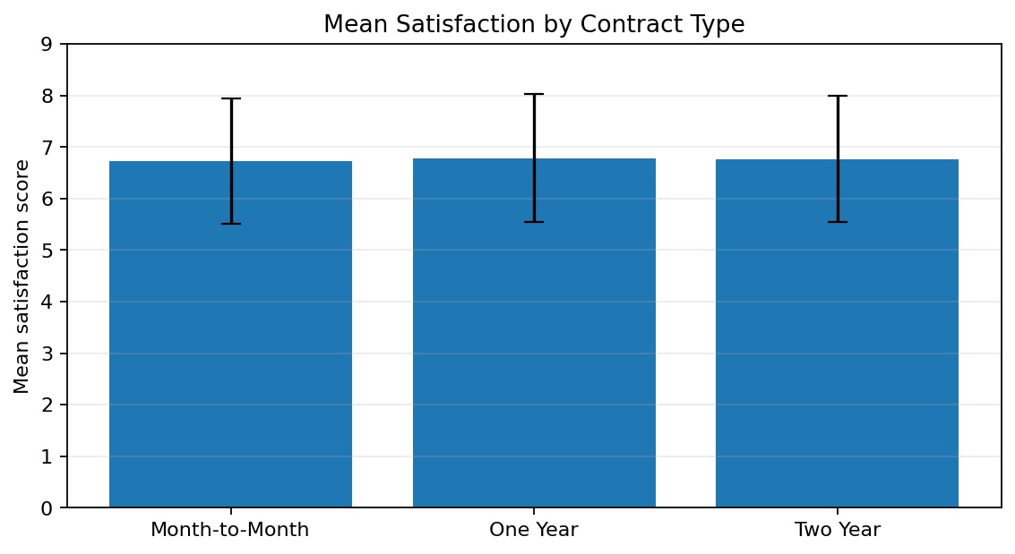
Figure 4. Mean satisfaction by contract type; error bars represent one standard deviation.

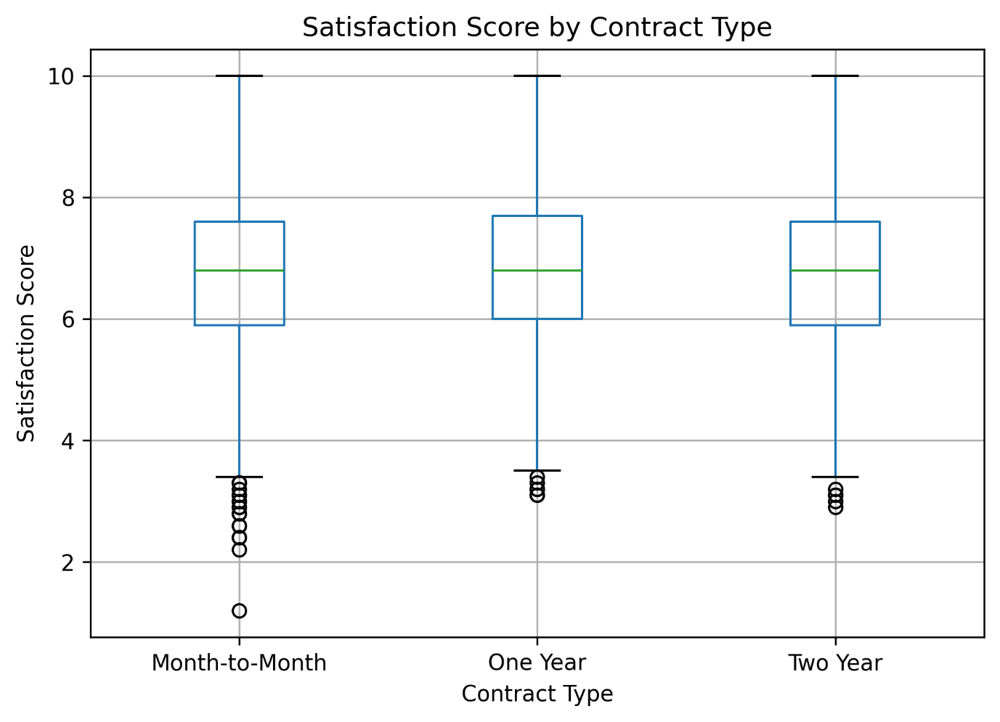
Figure 4. Mean satisfaction by contract type; box plot representation

Decision: Fail to reject H₀ because the ANOVA p-value (0.1388) exceeds 0.05. There is insufficient evidence that mean satisfaction differs across contract types. Eta-squared is approximately 0.000395, meaning contract type accounts for about 0.0395% of observed variation in satisfaction scores, a negligible effect in this analysis. Because the overall ANOVA was not statistically significant, post-hoc tests were not needed for the main conclusion.

6. Overall Findings and Business Implications
Satisfaction and churn: Churned customers had lower average satisfaction. Satisfaction and customer experience are useful areas to examine in retention analysis.
Contract type and churn: Month-to-Month customers had the highest observed churn rate. The business could investigate targeted onboarding, retention support, or suitable longer-term plan options for this group.
Satisfaction and contract type: Mean satisfaction scores were similar across contract types. Contract type alone should not be used to infer satisfaction.
Further analysis: Additional customer characteristics and validated predictive models may help identify churn patterns; any model should be evaluated before operational use.

7. Limitations
The tests identify differences or associations, not cause-and-effect relationships.
The findings are based on one dataset and may not generalize to other organizations or time periods.
Group averages do not describe every individual customer.
The chi-square test does not adjust for other variables that may be related to churn.

8. Conclusion
The analysis found strong statistical evidence that satisfaction differs between churned and non-churned customers, with churned customers reporting lower mean satisfaction. It also found a significant association between contract type and churn, with the Month-to-Month group showing the highest churn rate. However, there was no statistically significant evidence that average satisfaction differed by contract type, and the eta-squared effect was negligible. These findings identify useful areas for further retention analysis while recognizing that multiple customer characteristics may contribute to churn.

Python Code Submission
The complete Python code is submitted separately in the project notebook/script. This report therefore focuses on the dataset, statistical methodology, results, visualizations, interpretations, and conclusions.

